National Event Management Service (NEMS) Onboarding Guide

V1.6 August 2021

Document Management

Revision History

|  |  |  |  |
| --- | --- | --- | --- |
| Version | Date | Author | Summary of Changes |
| v0.4 | 10/08/2020 | James Lane | Updates:   * Details of the NEMS assurance stages * Elaborates TKW meaning * Updated contact details – route of entry * Further details – TKW/INT testing requirements |
| v0.5 | 21/08/2020 | James Lane | Updated following review – grammatical changes |
| V1.0 | 28/08/2020 | James Lane | Updated with approval – processes in appendices changed to attachments |
| V1.1 | 17/11/2020 | James Lane | Cosmetic changes based on feedback, additions to NEMS Assurance Stages to mirror format of NRL onboarding guide, clarity of Catbag codes, INT environment connection section updated, failover issue addressed. |
| V1.2 | 26/01/2021 | Harry Plummer | -Addition of MESH mailbox instructions  -Additional DCH elements added to FAQ |
| V1.3 | 08/02/2021 | Soumya Jayaram | Removed specific text, included diagrams and cleaned up the document. |
| V1.4 | 01/06/2021 | Soumya Jayaram | Updated Onboarding Guide for Dynamic DNS prerequisite |
| V1.5 | 26/07/2021 | Harry Plummer | Removed IWG email contact and replaced with NRL/NEMS Team Mailbox |
| V1.6 | 11/08/2021 | Harry Plummer | Amended MESH request section |

Reviewers

This document has been reviewed by the following people:

| Reviewer Name | Title / Responsibility | Date | Version |
| --- | --- | --- | --- |
| Raman Behl | NEMS / NRL Clinical Lead | 25/08/2020 | v1.0 |
| Andy Quinn | NEMS Project Manager | 25/08/2020 | v1.0 |
| James Cox | NEMS Technical Architect | 25/08/2020 | v1.0 |
| Rebecca Thirsk | Principal Business Analysis Manager | 25/08/2020 | v1.0 |
| Rebecca Snape | NEMS / NRL Product Manager | 25/08/2020 | v1.0 |
| Shail Ravjibhai | DCH Business Analysis Manager | 25/08/2020 | v1.0 |
| Jon Maslen | NEMS / NRL Product Owner |  | V1.3 |
| Rebecca Snape | NEMS / NRL Product Manager |  | V1.3 |

Approved by

This document must be approved by the following people / boards:

| Name | Signature | Title | Date | Version |
| --- | --- | --- | --- | --- |
| Gemma Beacock |  | NEMS / NRL Product Owner | 28/08/2020 | v1.0 |
| Jon Maslen |  | NEMS / NRL Product Owner |  | V1.3 |

Glossary of Terms

| Term / Abbreviation | What it stands for |
| --- | --- |
| AIDA | Applications and Infrastructure Design Authority |
| API | Application Programming Interface |
| ASID | Accredited System ID |
| BIDA | Business Interoperability Design Authority |
| CDA | Cyber Design Authority |
| DCH | Digital Child Health |
| DDA | Data Design Authority |
| DHSC | Department of Health and Social Care |
| DIP | Digital Interoperability Platform |
| DPIA | Data Protection Impact Assessment |
| DVP | Deployment Verification Period |
| FHIR | Fast Healthcare Interoperability Resources |
| HSCN | Health and Social Care Network |
| IG | Information Governance |
| IopS | Interoperability Standards |
| ITK | Interoperability Toolkit Standards |
| IWG | Interoperability Working Group |
| LHCR | Local Health Care Record |
| MESH | Message Exchange for Social Care and Health |
| N3 | NHS Secure National Broadband |
| NEMS | National Event Management Service |
| NHS | National Health Service |
| NHSD | NHS Digital |
| NRL | National Record Locator |
| NWR | New Work Request |
| ODS | Organisation Data Service |
| PDS | Person Demographic Service |
| PHE | Public Health England |
| RBAC | Role Based Access Control |
| SCAL | Supplier Conformance Assessment List |
| TCC | Technical Conformance Certificate |
| TKW | Toolkit Workbench |
| TRG | Technical Review and Governance |

Document Control:

The controlled copy of this document is maintained in the NHSD corporate network. Any copies of this document held outside of that area, in whatever format (e.g. paper, email attachment), are considered to have passed out of control and should be checked for currency and validity.

Contents

1 Introduction 8

1.1 Document Purpose 9

1.2 Audience 9

2 National Event Management Service 9

2.1 Overview 9

2.1.1 NEMS Vision 9

2.1.2 Publish / Subscribe Pattern 10

2.2 NEMS Data Flow 11

2.3 NEMS Eligibility 11

2.4 NEMS Principles 11

2.5 NEMS Prerequisites 12

3 NEMS Functionality 12

3.1 Overview 12

3.2 Event Messages 13

3.2.1 Event Maturity 13

3.2.2 Supported Generic Event Messages 14

3.2.3 Digital Child Health Event Messages 14

3.3 Publishing 14

3.4 Subscribing 14

3.5 Subscriptions Management 15

4 Onboarding Stages 15

4.1 Engagement 16

4.2 IWG 17

4.3 Pre-Onboarding 17

4.4 Assurance Stages 17

4.4.1 TKW 17

4.4.2 INT testing 18

4.4.3 Pre-Live 18

4.4.4 Live 18

4.5 Connecting to the NHS Digital Integration (INT) Environment 19

4.5.1 Instructions for End Point Registration (EPR) in the INT environment 19

4.5.2 INT Environment Connection Details for NEMS 20

4.6 MESH Mailbox 21

4 Onboarding Artefacts 22

5.1 Supplier Conformance Assessment List and Technical Conformance Certificate 22

5.1.2 Already completed a SCAL? 23

5.2 Connection Agreement 23

5.3 Data Sharing Arrangement 23

6 Live Service Implementation 24

6.1 Live Connecting Request 24

6.2 Supplier Access to NEMS Process 24

7 Post Implementation Support 25

7.1 Incident Management 25

7.2 Environment Maintenance 26

8 Appendix 27

8.1 NHS Digital Onboarding Supplier Task Checklist 27

8.2 Frequently Asked Questions 27

# 1 Introduction

NHS Digital has been directed[1] and commissioned to develop IT applications, IT infrastructure and IT systems necessary to operate and deliver the Digital Interoperability Platform (DIP). The DIP underpins the delivery of a set of national integrated care capabilities and services to inform clinical decisions across all health and care settings and improve the experience of service users by enabling and enhancing the flow of patient information.

NHS Digital provides several national technical capabilities intended to help industry and local health and social care providers enhance interoperability between IT systems and to flow information to support direct care[2] purposes, one of which is the National Event Management Service (NEMS).

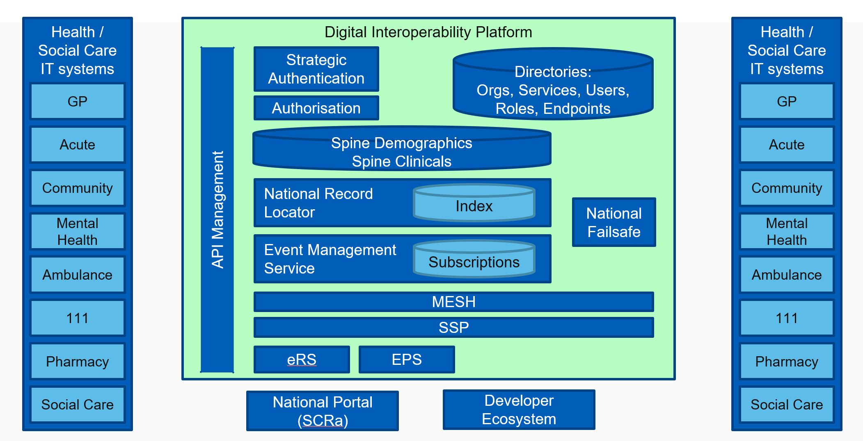

Figure 1: Digital Interoperability Platform

DIP patient information services bring together care information related to the patient in near real-time at the point of care and support wider sharing of records along care pathways and across organisational boundaries. In association, work is progressing to standardise integration through the development of application programming interface messages (APIs) and simplification of the operating model.

NHS Digital services which are enabled through the DIP include:

* GP Connect
* National Record Locator service (NRL)
* National Event Management Service (NEMS)
* Reasonable Adjustment Flag
* Summary Care Record application (SCRa)

## 1.1 Document Purpose

This guide provides guidance for a health and social care organisation wishing to publish and / or subscribe to the National Events Management Service (NEMS), containing detail from initial engagement, build and assurance through to implementation into live.

It includes:

* Key supporting links
* Reference material
* Associated guides providing additional detail

Where an end user organisation is developing an in-house solution for deployment, they are both a Supplier and EUO (End User Organisation) and must complete all the required onboarding steps in both capacities.

## 1.2 Audience

The intended audience for this document includes but not limited to:

* Health and social care organisations
* Health and social care IT system developers and suppliers
* Internal NHS Digital programmes and projects
* Other impacted Stakeholders who require access to Onboarding Process

# National Event Management Service

## 2.1 Overview

The National Events Management Service (NEMS) is a national service implemented on the [Spine](https://digital.nhs.uk/services/spine) and allows for patient-centric event messages to be published from one system and distributed to a number of other subscriber systems.

The NEMS is designed to be a generic transport mechanism which can support a variety of use cases and event types from several different care settings.

Event messages are intended to be generic (e.g., Person Demographic service (PDS) events such as Birth, Death) and for use in multiple care settings, however it is recognised that there may be some which are specific to a care setting.

Further detail on NEMs can be found on the Health Developer Network[3] and the [National Event Management Service](https://developer.nhs.uk/apis/ems-beta/) section.

### 2.1.1 NEMS Vision

For Health and Social Care Professionals who have a legitimate relationship with the patient / service user, the National Event Management Service is an event management brokerage service that facilitates the sharing of nationally defined patient / service user events between approved[4] health and care organisations, services, care-settings, professionals and patients / service users in near-real time and for direct care purposes.

Unlike the current systems and manual processes, the National Event Management Service enables the flow of data automatically across organisational and service boundaries in a consistent, standardised format in near-real time.  Access to the data is securely managed and controlled and the solution underpins the delivery of national strategies and the provision of digital interoperability capabilities to the health and social care ecosystem.

### 2.1.2 Publish / Subscribe Pattern

Where an application requires access to data captured and held on another application, there are five general patterns for managing this, all patterns are supported by NHS Digital and further detail can be found in the Appendix**:** Enterprise Architecture Policy: Integration Patterns.

The National Event Management Service adopts a Publish / Subscribe interoperability pattern, which means that an application that captures data publishes this to other applications referred to as subscribers. Key characteristics of a Publish / Subscribe Pattern are:

* those generating the information do not typically know all those who should receive it.
* those receiving the information do not typically know who produced it.
* the recipient(s) need to be informed that an event has occurred and can't wait until they next access the patient's record.

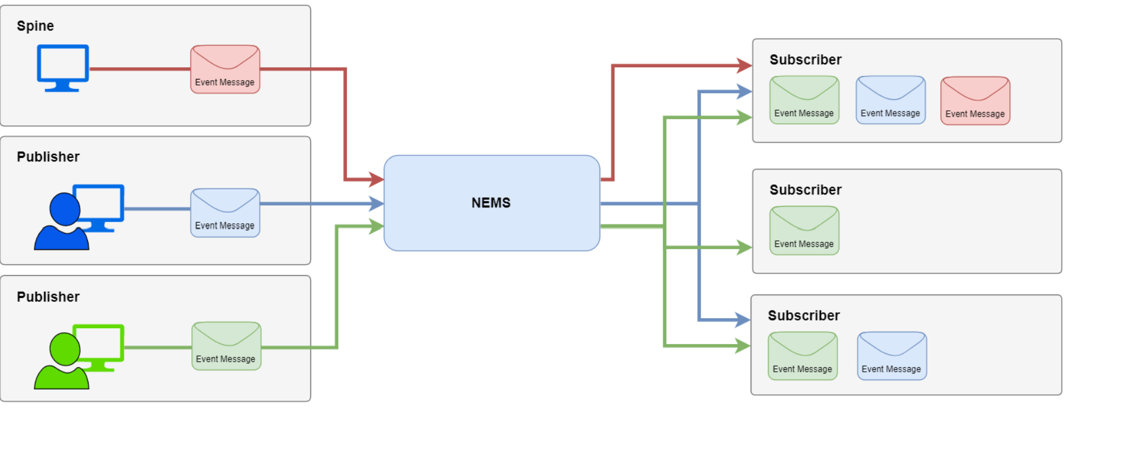

Figure 2 – High Level NEMS Flow

## 2.2 NEMS Data Flow



Figure 3 - NEMS Data Flow Diagram

## 2.3 NEMS Eligibility

As the National Event Management Service is a data-sharing capability, governance and assurance controls exist to ensure that only eligible health and social care organisations wishing to publish or subscribe to NEMS are approved to do so.

These controls ensure that information sharing requests are in keeping with NHS Digital’s information governance requirements and the DIP Direction.

Requests to publish or subscribe to existing events or to share new or changed ‘information flows’[5] are managed through the Interoperability Working Group and are triggered by the submission of an Information Flow Request form (available via: nrlnems.ls@nhs.net). Refer section 4.2 for more information.

## 2.4 NEMS Principles

* Genericity of events is maintained where possible to support reuse across eligible health and social care systems.
* New or changed requests to share information are fit for use and fit for purpose by users
* Use of NEMS
  + - Aligns to the architectural principles
    - Is underpinned by the appropriate information governance artefacts
    - Supports clinical safety
    - Is for direct care purposes

## 2.5 NEMS Prerequisites

The pre-requisites are contained in detail in the Supplier Conformance Assessment List (SCAL) as are the business requirements, however **key items** have been summarised here to help connecting parties identify potential showstoppers at an early stage.

**Technical**

1. PDS Compliancy. For information about searching using demographic information see <https://digital.nhs.uk/services/demographics>
2. Penetration Testing
3. A valid ODS (Organisation Data Service) code is required for the connecting party). The ODS Portal indicates if an organisation has a registered code: [NHS Digital ODS Portal](https://odsportal.digital.nhs.uk/)
4. N3 or HSCN connection. This is required for both live service and the online testing process.
5. A valid NHS Smartcard for all users or a system that uses an authentication method supported by NHS Identity or NHS Login. For more information about SmartCards, see <https://developer.nhs.uk/apis/spine-core/smartcards.html>
6. Publishers/Subscribers should be able to configure Dynamic DNS to interact with Live systems ( main and backup sites).

**Information Governance**

1. An organisation must have completed the DSPT (Data Security Protection Toolkit) within the last 12 months (<https://www.dsptoolkit.nhs.uk>).

**Clinical Safety**

Connecting parties must have an appointed Clinical Safety Officer and undertake a Clinical Safety Assessment prior to going live. Both the connecting party and the end user organization working as a publisher and/or consumer will need to evidence Clinical Safety Assessment has been completed and Hazard log reviewed through the completion of SCAL.

Based on the type of use case being onboarded, any additional requirements to the above process will be identified and advised by the onboarding team.

# NEMS Functionality

## 3.1 Overview

An approved organisation may be a NEMS publisher, subscriber or both, the functionality to be developed is summarised as:

* NEMS Subscription API
  + Creation and deletion of both generic and explicit subscriptions
  + Auditing of the management of subscriptions
  + Verification of NHS number prior to subscription creation
  + Conformance to the Information Governance requirements
* NEMS Publisher
  + Auditing of the published messages
  + Verification of NHS number prior to publishing
  + Conformance to the specific event construction and content
  + Conformance to the Information Governance requirements

The NEMS technical specification provides further detail and the requirements, it is located on the Health Developer Network: [National Event Management Service Technical Specification](https://developer.nhs.uk/apis/ems-beta/).

## 3.2 Event Messages

Each event message which passes through NEMS carries a standard set of event information to allow the receiver of the message to identify:

* the patient who is the focus of the event
* information about the provider who published the event message, including [contact details](https://developer.nhs.uk/apis/ems-beta/overview_msg_architecture_feedback.html) for issues with the event message
* information about the event that occurred
* information to allow receivers to perform [message sequencing](https://developer.nhs.uk/apis/ems-beta/overview_msg_architecture_sequencing.html)

Generic event messages are designed and intended for reuse across different organisations and care settings.

You can learn more about the type is events and subscriptions by accessing the below link

<[Introduction to National Events Management Service | Events-Management (developer.nhs.uk)](https://developer.nhs.uk/apis/ems-beta/index.html)>

### 3.2.1 Event Maturity

The maturity of an event message is indicated in the following tables, event maturity labels are intended to indicate the expected stability of the event messages.

|  |  |
| --- | --- |
| Event Maturity | Description |
| Alpha | Early proposal for an event message, high risk of change. |
| Beta | The event design has been agreed and is intended to become the release candidate but has not been proved through development and testing, therefore there is a risk that changes may be required. |
| Release Candidate | The event has been through a development and testing phase, followed by a successful Deployment Verification Period[6] (DVP) in live use. The event message should not change unless as a result of a live issue. |
| Released | Event is being widely used and is unlikely to change, unless a change is required as a result of a live issue. |

Table 3: Event Maturity Labels

### 3.2.2 Supported Generic Event Messages

The following are generic event messages supported by the NEMS.

The latest list of events supported by NEMS and the respective event maturity status is available on the API Specification document

<https://developer.nhs.uk/apis/ems-beta/overview_supported_events.html>

### 3.2.3 Digital Child Health Event Messages

The following event messages are supported by the NEMS but have been defined by Digital Child Health. Please refer to the link for a complete list of event messages

<https://developer.nhs.uk/apis/ems-beta/overview_supported_events.html>

## 3.3 Publishing

The following process outlines the high-level business process for the publishing of events to the National Event Management service.

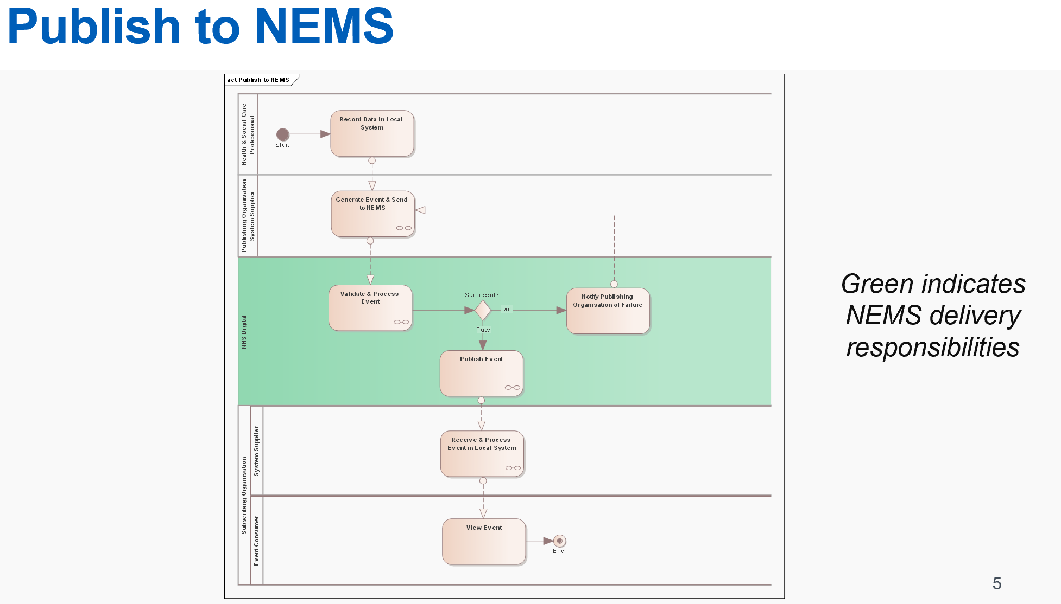

Figure 4: Publishing to NEMS Process

## 3.4 Subscribing

The following process outlines the high-level business process for subscribing to events from the National Event Management service.

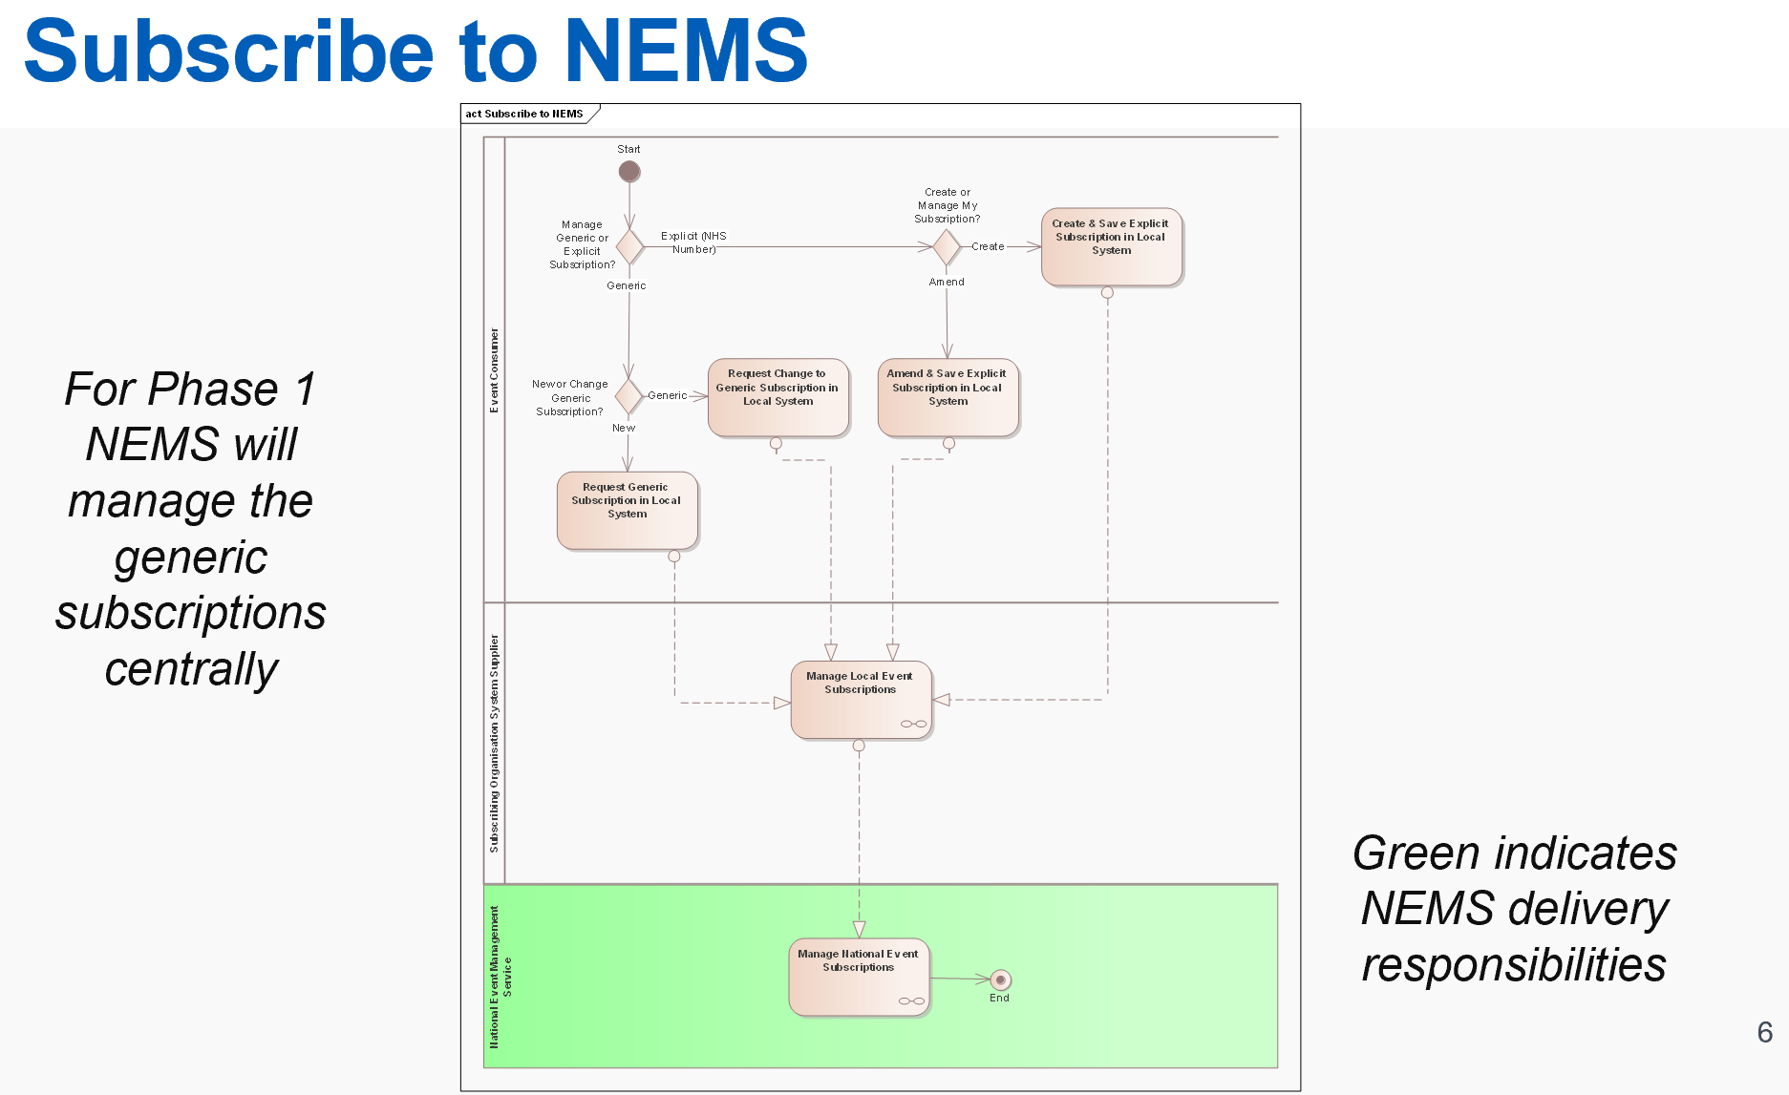

Figure 5: Subscribing to NEMS

## 3.5 Subscriptions Management

Different types of subscriptions supported by NEMS

* [Explicit Subscriptions](https://developer.nhs.uk/apis/ems-beta/explore_subscriptions.html#explicit-subscriptions)
* [Rule-Based (Generic) Subscriptions](https://developer.nhs.uk/apis/ems-beta/explore_subscriptions.html#rule-based-generic-subscriptions)
* [Multiple matched subscriptions](https://developer.nhs.uk/apis/ems-beta/explore_subscriptions.html#multiple-matched-subscriptions)

To receive event messages a consumer will need to subscribe to events they want to receive. The flow of event messages from publishers to subscribers is described on the [Messaging Architecture Overview](https://developer.nhs.uk/apis/ems-beta/overview_msg_architecture.html) page.

Follow link below to read through the Subscription Management process

[*Subscriptions Overview | Events-Management (developer.nhs.uk)*](https://developer.nhs.uk/apis/ems-beta/explore_subscriptions.html)

# Onboarding Stages



## Engagement

When ready to explore the NEMS service, please contact the NEMS team direct via [nrlnems@nhs.net](mailto:nrlnems@nhs.net) where the team will guide through the end-to-end process

Some of the steps include

* Assess suitability for NEMS via IWG process (See section 2.3 for further information).
* Detail the required NEMS Assurance stages to complete
* Ensure pre-requisites are met.
* Verify plans for development.
* Advise on next steps to begin testing.
* Issue the latest version of the Supplier Conformance Assessment List (SCAL) that is tailored to reflect any previous conformance testing undertaken with NHS Digital. (Refer section 5.1.1)

The team will verify that the organisation wishing to onboard to NEMS meets the basic entry criteria to use the product and the requestor has received Approval from the IWG to ensure that NEMS is the appropriate route to provide the service (refer to section 2.3).

To use the service organisations MUST have most of these pre-requisites in place prior to starting development activities along with the approval from the IWG

**Note:**The Developer site provides materials enabling organisation to begin local testing activities, but the NRL team can accept no responsibility in the event that permission to proceed with onboard with NRL is rejected. 



## IWG

The NHS Digital Interoperability Working Group is a panel of subject matter experts (SMEs) analysing information sharing requests and providing recommendations, the group membership represents the following professions:

* Clinical
* Information Governance
* Business (Live Services)
* Technical Architecture

The NHSD onboarding team will guide you through the required documentation to support the process. Please contact team via email at [nrlnems@nhs.net](mailto:nrlnems@nhs.net)

Requests are assessed by a multidisciplinary team with representation from the business, clinical safety, information governance and technical architecture to determine:

* Validity of the sharing request
* Necessity, proportionality, and lawful basis
* The organisation’s and it’s end user’s appropriateness for the sharing of the information
* Appropriate architectural pattern to apply based on the end user needs

## 4.3 Pre-Onboarding

Following an approval from IWG to proceed with NEMS, the onboarding team will work with the requesting organisation to go over pre onboarding check list and walk-through steps to initiate testing phases.

## 4.4 Assurance Stages

### 4.4.1 TKW

Following completion of pre-requisites activities, the team will grant authority to proceed Local (TKW) Testing activities.

Steps

* Receive a copy of the SCAL
* Work with NHS Digital Solutions Assurance team in relation to below activities
  + to obtain a copy of Test scripts
  + Obtain access to *Opentest* environment

To proceed to INT testing, the organisation MUST demonstrate they can validate messages against the TKW as per the NHS Digital Solutions Assurance team requirements.

### 4.4.2 INT testing

The NHS Digital INT Environment is a *sandbox* environment for testing the functionality to NEMS and a pre-test to ensure that the organisations development is safe to use on the Live Spine environment.

Steps involved in this phase include

1. Access to the INT environment will be setup prior to completing TKW activities to avoid delays. Details on requesting setup to INT can be found in section 4.3
2. Continue working with the NHS Digital Solutions Assurance (SA) team executing the test cases provided and record test evidence to share with SA team
3. Request catbag codes

[ Contact [nrlnems.ls@nhs.net](mailto:nrlnems.ls@nhs.net) to receive these]The types issued are subjective to what event types and subscription types have been approved at IWG.‘Cat bag’ properties are used on a user’s ASID to determine what events a user is permitted to subscribe to, and what kinds of subscriptions a user is permitted to create.]

1. Receive Technical Conformance Certificate (TCC)

(Once the Solutions Assurance team are satisfied the test requirements are met a Technical Conformance Certificate (TCC) will be issued to confirm suitability for go-live.)

1. Update SCAL to reflect the testing activities.

***Note***: - It is suggested that the requesting organisation perform a full end to end test within the DEP environment to support smooth transition to Live environment. This will allow the Requesting organisation to resolve any issues recognised in the DEP (Deployment) environment.

### 4.4.3 Pre-Live

Before an organisation is granted access to a live environment they would be expected to sign:

* A Connection Agreement (agreement between Connecting Party and NHSD) see section (5.2)
* Data Sharing Arrangement (DSA) – Responsibility of the data processor to ensure that it is circulated and agreed with all data controllers (*see section 5.3*)

**Note:** to avoid delays to go-live these agreements maybe provided earlier.

The organisation will also run through a Go-No Go Checklist with the NEMS team to ensure all requirements have been met.

### 4.4.4 Live

With all assurance requirements complete, the organisation moves NEMS into business-as-usual activities. For further support while live please see section 7.

## 4.5 Connecting to the NHS Digital Integration (INT) Environment

### 4.5.1 Instructions for End Point Registration (EPR) in the INT environment

The following section provides the basic steps for connecting to the INT environment for the specific purpose of undertaking conformance testing with NEMS.

Further levels of detail, including generic guidance for how to connect to the NHS Digital INT environment can be found on the [NHSD Path to Live](https://digital.nhs.uk/services/path-to-live-environments/integration-environment) intranet pages.

The following should be noted when reading the above linked guidance, specifically for the purposes of Conformance Testing with NEMs:

* Requesting access to test data is not required for conformance testing with NEMS.
* Whilst Smartcards are a requirement to consume NEMSas a subscriber in the Live environment, they are not necessarily required to complete conformance testing with the NEMS in the INT environment. Similarly, Identity Agent client software is not necessarily required to complete conformance testing with the NEMs in the INT environment.

Any questions or request for support should be addressed to the NHS Digital Platforms Support Desk: [platforms.supportdesk@nhs.net](mailto:platforms.supportdesk@nhs.net)

1. **Register Messaging Product**

<https://digital.nhs.uk/forms/manufacturer-product-version-registration-request>

Use the above link to provide the product name and version, organisation name and ODS code, which will be registered in the INT environment.

1. **Create endpoint and certificate:**

<https://digital.nhs.uk/forms/combined-endpoint-and-service-registration-request>

In order to complete the End Point Registration to the Integration (INT) Sandpit Environment, a Certificate Signing Request (CSR) must be provided and contain the following:

* Keylength: 2048
* CN (Common Name): ***the FQDN***
* Country Code:GB

All other details should be left blank.

NHS Digital has experienced problems in the past when creating a CSR using SSL Win-32 so it is recommended that SSL Win-64 is used. All certificates that are to be used to connect to the spine must have a distinguished name that contains a CN, or Common Name.

1. **Register the Fully Qualified Domain Name (FQDN) with the NHS DNS team:**

<https://digital.nhs.uk/forms/dns-request-form-for-path-to-live-environments>

Provide the HSCN-facing IP address, (with an appropriately formatted test FQDN), so that it can be registered on the NHS Digital DNS.  
Note that the following requirements for endpoints must be met:

* 1. The FQDN must end in nhs.uk
  2. Endpoints must be on port 443
  3. Endpoints must not include explicit port declarations (e.g. :443)

1. **Configure Firewalls:**

Make sure firewalls allow appropriate inbound and outbound messages. The next section (INT Environment Connection Details for NEMS) will be of assistance.

1. **Complete Local Environment Setup:**

Once NHSD has the CSR and the Service Registration has been completed the Party Key will be sent, ASID and digital certificate to enable connection to the INT environment for the final tests.

### 4.5.2 INT Environment Connection Details for NEMS

NEMS URL:

For subscription

<https://msg.int.spine2.ncrs.nhs.uk/STU3/Subscription>

For events like NIPE outcome, new born, blood spot etc (Digital Child Health events).

<https://msg.int.spine2.ncrs.nhs.uk/STU3/Events/1/$process-message>

IP Address: 10.239.14.26

1. Port: 443 TCP
2. Spine Party Key: YES-0000806
3. NEMS ASID: 200000000306
4. SSP Proxy URL: proxy.int.spine2.ncrs.nhs.uk
5. IP Addresses:  10.239.14.31
6. Port: 443 TCP
7. LDAP URL**: ldap.nis1.national.ncrs.nhs.uk
8. IP Address: 10.196.94.141
9. Port: 636 TCP

**Note:** When setting up connection with NEMS, the connecting supplier system should use the NEMS URL and NOT the NEMS IP Address. This is because NEMS is setup with a primary and secondary server in the spine, both which have separate IP Addresses.

Therefore, the supplier system should not be hard coded to connect to the NEMS IP Address, otherwise this will result in connection issues should the spine failover.

## 4.6 MESH Mailbox

*Please note that INT and DEP MESH mailboxes are set up by the platforms support team (platforms.supportdesk@nhs.net) and Live MESH mailboxes are set up by National Service Desk (ssd.nationalservicedesk@nhs.net).*  
**Requesting MESH mailbox for INT/DEP**

To set up a mailbox for INT or DEP, the requesting party should email the Platforms Support Desk (platforms.supportdesk@nhs.net), stating which workflow ID they want on their mailbox and give the following information:  
  
• your organisation name and address  
• your organisation data service (ODS) code  
• the contact details of a nominated representative within your organisation  
• the contact details for any third-parties managing the mailbox on your behalf  
• the type of data you'll be sending and receiving via MESH  
• the approximate file size of the data you'll be sending  
• Which Workflow IDs you need adding to the MESH mailbox  
  
Suppliers will then be given a reference number from the Platforms Support Desk, which should be quoted when contacting the team for any updates or follow on discussions.

**Requesting MESH mailbox for Live**

The form to request a live MESH mailbox is available at: <https://digital.nhs.uk/services/message-exchange-for-social-care-and-health-mesh/messaging-exchange-for-social-care-and-health-apply-for-a-mailbox> .

Within the form you need to ensure the following question is ticked ‘Yes’

**Is this mailbox for National Events Management Service (NEMS) use?**

Guidance embedded below –‘Authority to proceed – MESH Mailbox’ on which workflow ID’s you need to request out of the nine approved NEMS events in the online MESH form, these need to be correctly added to your MESH mailbox. You will need this information included for **each** NEMS event required under the following heading on the online form ‘What type of data will you be sending/receiving via MESH?’. You also need to include initiate and / or respond information.

[Authority to proceed - MESH Mailbox](https://hscic365.sharepoint.com/:w:/r/sites/NRLNEMSOperations/Shared%20Documents/External%20Access/Authority%20to%20proceed%20-%20MESH%20Mailbox%20v0.2.docx?d=wc1dfd3c71a944a089af46b1ac69d3968&csf=1&web=1&e=2oqFzF)

**ODS codes**

As part of the generic subscriptions/provider specific subscriptions, when a MESH mailbox is being set up for a customer/provider, it is that ODS code that must be populated.   
   
When you are requesting a mailbox, this must be related to the ODS code of your customer and not your supplier ODS code. Therefore, for future rollouts a different MESH mailbox will be required for each provider ODS code.

**Messaging sequence**

MESH does not guarantee that messages published in a chronological order will be received in a chronological order.

Suppliers who receive messages via MESH will need to be able to handle out of order sequencing of messages, meta.lastUpdated element facilitates this,

e.g. https://developer.nhs.uk/apis/ems-beta/vaccinations_1.html : "To allow a consumer to perform message sequencing, the event MUST include the meta.lastUpdated element within the MessageHeader resource allowing the consumer to identify the latest and most up to date information".

# Onboarding Artefacts

There are several key artefacts that support Technical Conformance and the integration with NHS Digital Services:

* Supplier Conformance Assessment List (SCAL)
* Connection Agreement (CA)
* Technical Conformance Certificate (TCC)
* Data Sharing Arrangement (DSA)

## 5.1 Supplier Conformance Assessment List and Technical Conformance Certificate

The purpose of the Supplier Conformance Assessment List (SCAL) is for a product supplier (or End User Organisation (EUO) if developing an 'in-house' product) to declare and record that it meets or complies with a range of organisational, technical (product) and compliance requirements including those for Information Governance and Security, Clinical Safety and individual user interaction.

The information provided in the SCAL helps EUOs to assure themselves that the Product has been developed according to various quality and compliance requirements and standards. Any queries about the information provided in the SCAL is the developing party’s responsibility to address.

The SCAL underpins the technical conformance process and is referenced in the Connection Agreement (CA) that every Supplier must sign before their Product can connect to NHS Digital Service(s).

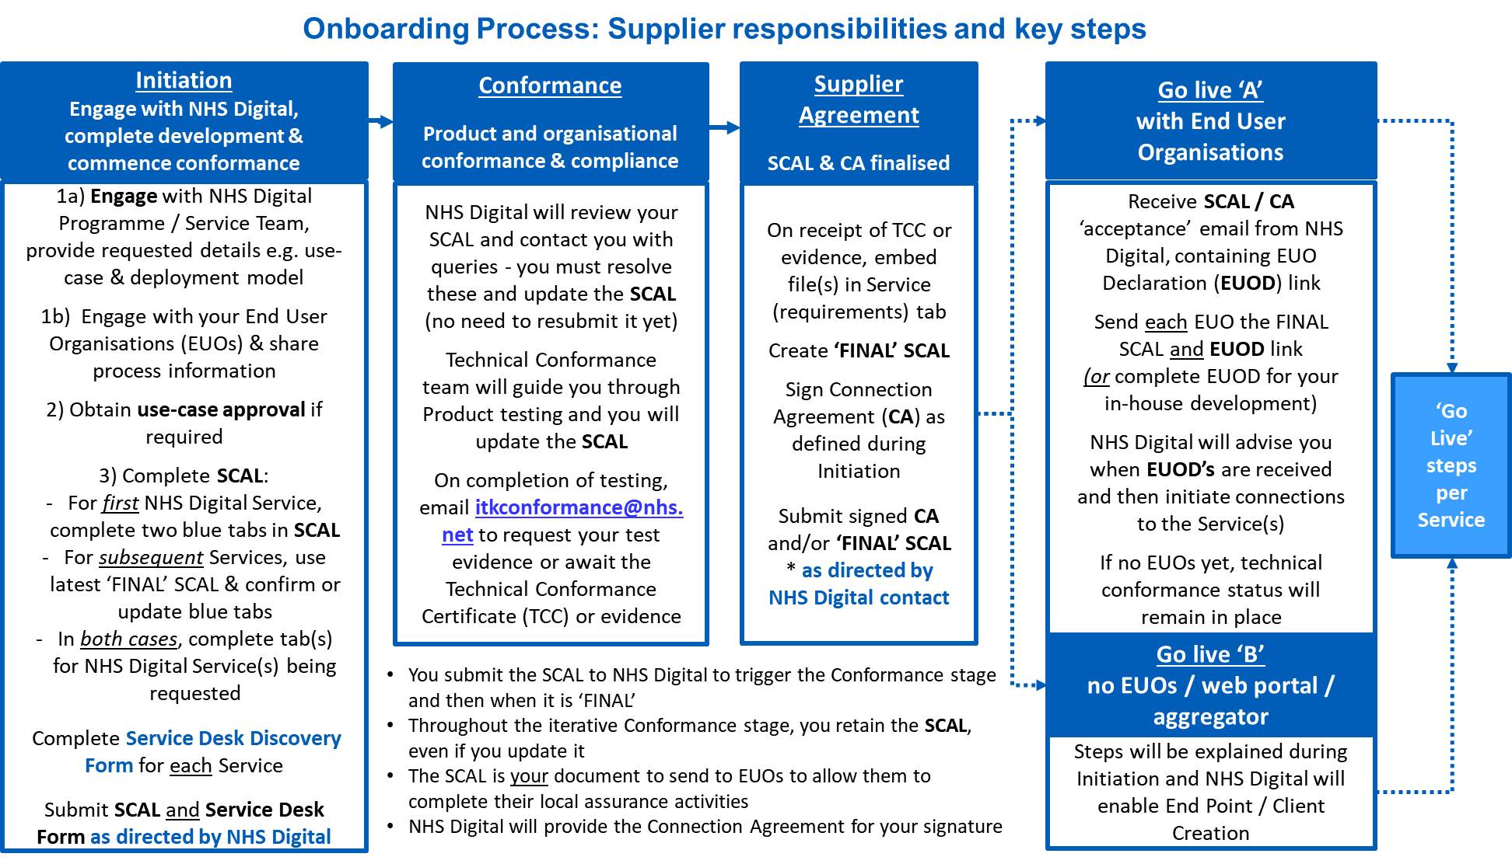

Figure 6 - Supplier Connection Assessment List

A SCAL is per (supplier) product, however the a single SCAL can cover integration to more than one NHS Digital Service.

* Maps all the requirements needed to interface with a specific service and the evidence required during technical conformance process and is supplier / product focussed.
* Within the SCAL, the connecting party logs where a product meets the technical, information governance and clinical safety requirements in a technical and business context.
* Many sections of the SCAL can be completed in parallel to the testing so it is recommended that all connecting parties familiarise themselves with the SCAL as early in the process as possible.
* On successful completion of the SCAL process a Technical Conformance Certificate (TCC) is issued

### 5.1.2 Already completed a SCAL?

There are two approaches to completing this document, dependent on whether the organisation has already completed a SCAL for an NHS Digital product.

* *If the organisation has previously completed a SCAL for an NHS Digital product*: the organisation will need to **update** the *‘General’* and *‘Architecture’* tabs and **complete** the required NEMS tabs.
* *If the organisation has NOT completed a SCAL for an NHS Digital product*: the organisation will need to **complete** the *‘General’* and *‘Architecture’* tabs, **and** the required NEMS tabs.

**Note:** The SCAL is a working document and will be updated throughout the stages to reflect testing activities and evidence.

The SCAL contains guidance to help populate the required information to complete assurance requirements for onboarding.

## 5.2 Connection Agreement

* The Connection agreement is the agreement with the connecting party who is processing the data (this is either the publisher or consumer) either as a processor subject to contract with a provider, or as the controller for the data and health and care provider.
* Agreement formed between the Connecting party and NHS Digital. comprises of a set of terms and conditions, links to the SCAL, and any Special Terms for a service and exists as an agreement for the duration of connection to the service.
* References End User Organisations and Individual End User obligations.
* Only needs to be completed by organisation directly connecting to NHS Digital systems.

## 5.3 Data Sharing Arrangement

Controllers are also expected to sign a Data Sharing Arrangement (DSA) that sets out their data protection responsibilities as controller for the event message, either as subscriber or publisher. DSA, is the responsibility of the connecting party to ensure the DSA is made available to their end users and they agree to the arrangement

# Live Service Implementation

## 6.1 Live Connecting Request

Once the following activities have been completed, live connection details can be requested from the onboarding lead ([nrlnems@nhs.net](mailto:nrlnems@nhs.net)).

1. Technical Conformance Testing Completed by Supplier
2. SCAL completed by supplier and accepted by NHS Digital
3. Connection Agreement signed and returned by Supplier
4. Data Sharing Arrangement completed by End User Organisation

## 6.2 Supplier Access to NEMS Process

All requests to onboarding to NEMS, will be actioned through the NRL/NEMS Live services team. Please contact the NEMS team (nrlnems.ls@nhs.net)

# Post Implementation Support

As the National Event Management Service does not look at the content of an event where there are issues with:

|  |  |  |
| --- | --- | --- |
| Scenario Title | Summary | Expected Outcome |
| Clinical Data Quality / Content | Issues with the quality or content of the data e.g. incorrect codes used | * Local discussion with the Publishing Organisation to address issues * No NHSD involvement |
| Event Message Structure | Unable to consume events in the local system | * Initial local investigation and diagnosis completed to determine if:   + Aligns to latest version of FIHR profile   + Certificate has expired * Not expected that this would require NHSD involvement |
| Event Subscriptions | I do not know who this person is | * Initial local investigation and diagnosis completed to determine if:   + Subscriptions are accurate   + May require NHSD involvement following local investigation and diagnosis |
| Event Disruption | I’ve stopped receiving events for a patient I have a legitimate interest | * Initial local investigation and diagnosis, reasons may include: * S Flag has been applied in PDS (events are not sent) * Subscription may have failed / become corrupted |

## 7.1 Incident Management

Please refer to this document to Incident Management process



NHS Digital National Service Desk:

* Tel: 0300 3 035 035
* Email: [ssd.nationalservicedesk@nhs.net](https://hscic365.sharepoint.com/sites/IP/National%20Record%20Locator%20Phase%202/Requirements/Processes%20and%20Guidance/ssd.nationalservicedesk@nhs.net)
* [Weblog](https://nww.serviceportal.digital.nhs.uk/CherwellPortal/NHSD#0) – Account Creation Required (see guide)



## 7.2 Environment Maintenance

During the onboarding process, all connecting parties will be added to the Platforms Support Newsletter distribution list. The newsletter informs users of forthcoming changes to the NEMS Service that are deployed to the NEMs test environments (this is currently the Integration environment and referred to as INT for short) prior to Live.

If these newsletters are not received in the first two weeks following go-live, contact the Platforms Support Desk ([platforms.supportdesk@nhs.net](mailto:platforms.supportdesk@nhs.net)) to request to be added to the distribution list.

# Appendix

## 8.1 NHS Digital Onboarding Supplier Task Checklist

The following activities are listed in an approximate chronological order as a guide only, to be tailored according to local working practices and processes:

1. Assign key resources to the project including:
   1. Primary Contact (e.g. project manager)
   2. Technical lead and/or developer(s)
   3. IG lead
   4. Clinical lead
2. All key resources to Review Onboarding Documentation.
3. Confirm Delivery Approach.
4. Commence Product Development.
5. Commence activities listed in SCAL
6. Commence any applicable local clinical safety assessments / processes.
7. Test development against reference implementation.
8. Complete TKW.
9. Complete Conformance Testing (NHSD Test Environment).
10. Update Business Processes and Train Users.
11. Obtain all necessary local approvals for go-live (e.g. clinical safety, board approvals).
12. Sign NHS Digital relevant commercial documents
13. Undertake implementation with NHS Digital.

## 8.2 Frequently Asked Questions

|  | FAQ | Response |
| --- | --- | --- |
|  | Where can I find the business requirements? | <https://developer.nhs.uk/apis/ems-beta/> |
|  | We have received an event and there are data quality issues, why won’t NHS Digital look at the content of an event when there are? | NHS Digital does not have the authority to view the events, issues with content must be discussed with the publisher. |
|  | Where can I see who is subscribing to which events? | The NEMS Data Controller Catalogue provides a current and forward view of NEMS publishers and subscribers.  The purpose of the controller catalogue is to document the system suppliers and health and social care organisations authorised to share information as events using the National Events Management Service (NEMS).  Any requests to share information via NHS Digital services, the source and consumer of that information, are reviewed by the Interoperability Working Group and a recommendation provided by the group as to the appropriate sharing pattern(s) and sharing capability(ies) which meet end user needs.  <https://developer.nhs.uk/apis/ems-beta/controller_catalogue.html> |
|  | Why do we have to complete the SCAL for each new event? | Each new event requires a retest of some (not all) of the requirements. Additionally, as each new event carries new data it is important to test that events are managed in the expected way. |
|  | Why is PDS compliancy required to be able to publish or subscribe to NEMS? | To validate and verify that subscriptions are correct, and events are correctly published. |
|  | Can NEMS be used in conjunction with the National Record Locator? | Yes it can where this meets the business needs. |
|  | How do I get assured to use PDS for DCH NEMS? | As PDS compliancy is a pre-requisite of publication or subscription to NEMS, this is managed as part of the onboarding and assurance process. Where a supplier has not yet achieved PDS compliance this will form part of that process, this is managed by live services where appropriate. |
|  | What is the difference between change of address and change of GP in NEMS? | A change of address event is published by PDS where it is notified of a change of address for a patient. A change of GP is published by PDS where it is notified of a change of GP registration for a patient. They may not occur at the same time as a child, or indeed any patient, may change address without the requirement to register with a new GP. |
|  | In order to process NEMS events, we will need to link the ingested data to a message identifier so we can deal with subsequent updates and deletes for that data item. What is the format for this identifier? | Consider NEMS Vacc spec https://developer.nhs.uk/apis/ems-beta/vaccinations_1.html: 1) logical "id" values in NHS Digital Vacc XML examples make use of UUIDs as these are one solution that meets the requirement of being a logical identifier that can be used to navigate between the resources contained within an instance of a FHIR bundle. See http://hl7.org/fhir/STU3/bundle.html#references . However use of UUIDs is not required. 2) identifier values . Implementation guidance says "A publisher defined unique identifier". Hence, again use of UUIDs is not required. The important thing, as per example, is that the system value (namespace) and publisher's identifier value are unique, e.g. the following is acceptable :  <identifier>  <system value="https://www.tpp-uk.com/identifiers"/>  <value value="TPP_123"/> </identifier>  If for example, "TPP_123" was "re-used" across multiple instances of SystmOne, then the system (namespace) would have to be reflect this, to maintain uniqueness, e.g.  <identifier>  <system value="https://www.tpp-uk.com/identifiers/sitex"/>  <value value="TPP_123"/> </identifier>  <identifier>  <system value="https://www.tpp-uk.com/identifiers/sitey"/>  <value value="TPP_123"/> </identifier> |
|  | How do I request for my INT/DEP endpoints get updated? | Please contact [nrlnems.ls@nhs.net](mailto:nrlnems.ls@nhs.net) to be assisted further. |
|  | Where do I find the latest FHIR profiles? | The latest FHIR profiles are now on the NEMS Specification and can be found on the message pages/generic guidance page. |

1. https://digital.nhs.uk/about-nhs-digital/corporate-information-and-documents/directions-and-data-provision-notices/secretary-of-state-directions/establishment-of-systems-digital-interoperability-platform-2019#purpose
2. A clinical, social or public health activity concerned with the prevention, investigation and treatment of illness and the alleviation of suffering of individuals. It includes supporting individuals’ ability to function and improve their participation in life and society. It includes the assurance of safe and high quality care and treatment through local audit, the management of untoward or adverse incidents, person satisfaction including measurement of outcomes undertaken by one or more registered and regulated health or social care professionals and their team with whom the individual has a legitimate relationship for their care. (Source: https://www.gov.uk/government/publications/the-information-governance-review)
3. <https://developer.nhs.uk/>
4. An organisation which has completed the NHS Digital Interoperability Working Group and a recommendation that the use of NEMS best meets the user needs.
5. The term information flow is used to delineate between the initial request to share information and the IWG’s recommended architectural pattern e.g., event (and there NEMS) or record pointer (and therefore the National Record Locator (NRL))
6. Agreed period of stability